IGU2013 Kyoto Regional Conference

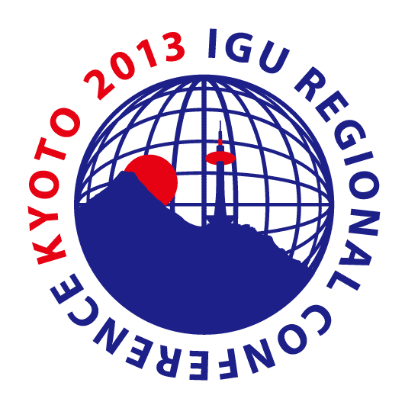
November 24-27, 2012, Kyoto, Japan
Exhibitor Application Form
Attention: Logistic Office for the KRC
c/o Japan Convention Services, Inc. Kansai Branch Office
2F Keihanshin Yodoyabashi Bldg. 4-4-7 Imabashi, Chuo-ku, Osaka, Japan 541-0042
Fax: 06-6221-5939 E-mail: igu2013-jcs@convention.co.jp

※ Fill in the required information and fax to the above office. / Application deadline: March 29 （Fri.）, 2013

Applied Date | (month/day/year)
Company Name | (Japanese) if available
Company Name | (English)
Company Address | Address:
Company Address | City: Province: Country: Zip:
Person in Charge | Name
Person in Charge | Department or Division
Person in Charge | Tel
Person in Charge | Fax
Person in Charge | E-mail
Booth Type  &  Quantity | Booth Type 1 | (138,000 JPY) × |  | Qty.＝ |  | JPY
Booth Type  &  Quantity | Booth Type 2 | (230,000 JPY) × |  | Qty.＝ |  | JPY
Booth Type  &  Quantity | *All prices include 5% consumption tax.
Planned items to exhibit
Comments | (Specify any other requests in the space below.)

